**Task 01:** Complete the tables with required data. --50 points

**Task 02:** Attach TWO screenshots of the simulated circuits during taking data for table 01 and table 02.

--50 points

**Task 03:** Draw the input and output characteristics of BJT. Label the graph properly by mentioning the name of different regions.

(Drawing can be hand-drawing using pencil & paper or using other smart-tools on PC)

**Name & ID:** Md. Rifat Ahmed ~ 1931725042

**Task 01:**

### Table 1: Input Characteristics of BJT

|  |  |  |  |  |  |  |  |
| --- | --- | --- | --- | --- | --- | --- | --- |
| $V_{CE }$ = 1 V | | | | $V_{CE }$ = 5V | | | |
| $V_{BB}$**(Volts)** | $V_{BE }$**(Volts)** | $V_{RB }$**(Volts)** | $${ I}_{B}=V_{RB }/R_{B}$$ (**μA)** | $V_{BB}$**(Volts)** | $V_{BE }$**(Volts)** | $V_{RB }$**(Volts)** | $${ I}_{B}=V_{RB }/R_{B}$$ (**μA)** |
| 0.1 | 100mV | 0V | 0A | 0.1 | 100mV | 0V | 0A |
| 0.2 | 200mV | 0V | 0A | 0.2 | 200mV | 0V | 0A |
| 0.3 | 300mV | 0V | 0A | 0.3 | 300mV | 0V | 0A |
| 0.5 | 200mV | 24.844mV | 0A | 0.5 | 500mV | 24.444mV | 0A |
| 0.7 | 677mV | 23.168mV | 0A | 0.7 | 677mV | 23.168mV | 0A |
| 1.0 | 739mV | 260.573mV | 2.61µA | 1.0 | 739mV | 260.573mV | 2.61µA |
| 3 | 795mV | 2.205V | 22.1µA | 3 | 795mV | 2.205V | 22.1µA |
| 5 | 811mV | 4.189V | 41.9µA | 5 | 811mV | 4.189V | 41.9µA |
| 7 | 821mV | 6.179V | 61.8µA | 7 | 821mV | 6.179V | 61.8µA |
| 10 | 832mV | 9.168V | 91.7µA | 10 | 832mV | 9.168V | 91.7µA |
| 14 | 841mV | 13.159V | 132µA | 14 | 841mV | 13.159V | 132µA |

Here, we’re considering 0V and 0A for values that are too small like nV, pA, nA.

**Table 2: Output Characteristics of BJT**

|  |  |  |  |  |  |  |
| --- | --- | --- | --- | --- | --- | --- |
|  | ${ I}_{B}$ = 10 **μA** | | | ${ I}_{B}$ = 50 **μA** | | |
| $V_{CC}$**(Volts)** | $V_{CE }$**(Volts)** | $V_{RC }$**(Volts)** | $${ I}_{C}=V_{RC }/R_{BC}$$ (**mA)** | $V_{CE }$**(Volts)** | $V_{RC }$**(Volts)** | $${ I}_{C}=V_{RC }/R_{BC}$$ (**mA)** |
| 0.1 | 51.2mV | 48.81mV | 48.81A | 31.7mV | 68.252mV | 68.252µA |
| 0.3 | 87.5mV | 212.479mV | 212.479µA | 51.6mV | 248.45mV | 248.45µA |
| 0.5 | 109mV | 391.104mV | 391.104µA | 63.8mV | 436.23mV | 436.23µA |
| 0.7 | 128mV | 572.499mV | 572.499µA | 72.7mV | 627.274mV | 627.274µA |
| 0.9 | 148mV | 751.58mV | 751.58µA | 80.0mV | 820.026mV | 820.026µA |
| 1.0 | 162mV | 837.847mV | 837.847µA | 83.2mV | 916.834mV | 916.834µA |
| 1.2 | 219mV | 981.124mV | 981.124µA | 89.0mV | 1.111V | 1.111mA |
| 1.5 | 498mV | 1.002V | 1.002mA | 96.6mV | 1.403V | 1.403mA |
| 2.0 | 998mV | 1.002V | 1.002mA | 108mV | 1.892V | 1.892mA |
| 2.5 | 1.5V | 1.002V | 1.002mA | 118mV | 2.382V | 2.382mA |
| 3.0 | 2.0V | 1.002V | 1.002mA | 128mV | 2.872V | 2.872mA |
| 5.0 | 4.0V | 1.002V | 1.002 mA | 202mV | 4.798V | 4.798mA |
| 10.0 | 9.0V | 1.002V | 1.002mA | 5.0V | 4.995V | 4.995mA |
| 15.0 | 14.0V | 1.002V | 1.002mA | 10.0V | 4.995V | 4.995mA |
| 20.0 | 19.0V | 1.002V | 1.002mA | 15.0V | 4.995V | 4.995mA |

**Task 02:**

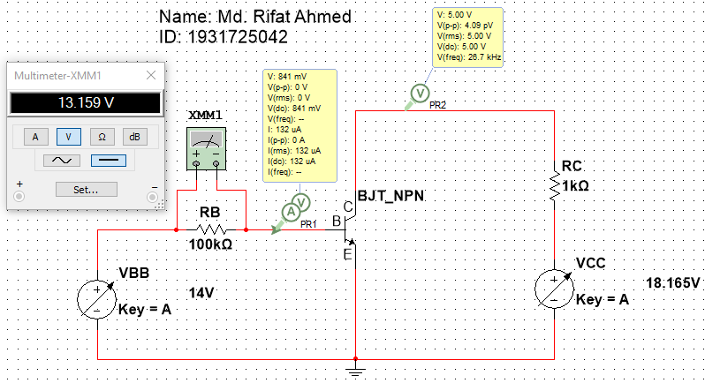

Figure 1 – Circuit to get the values for the Input characteristics of BJT

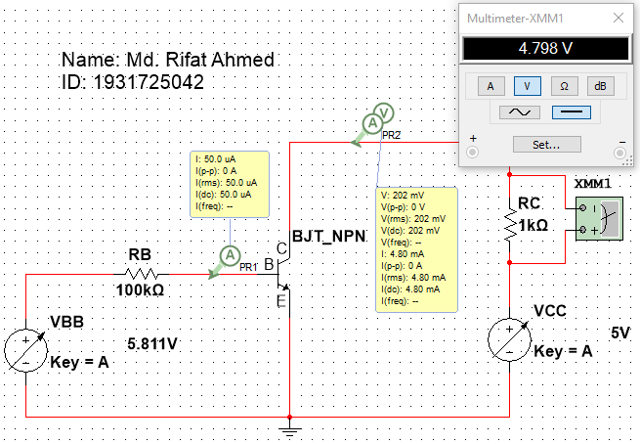

Figure 2 – Circuit to get the values for the Output characteristics of BJT

**Task 03:**

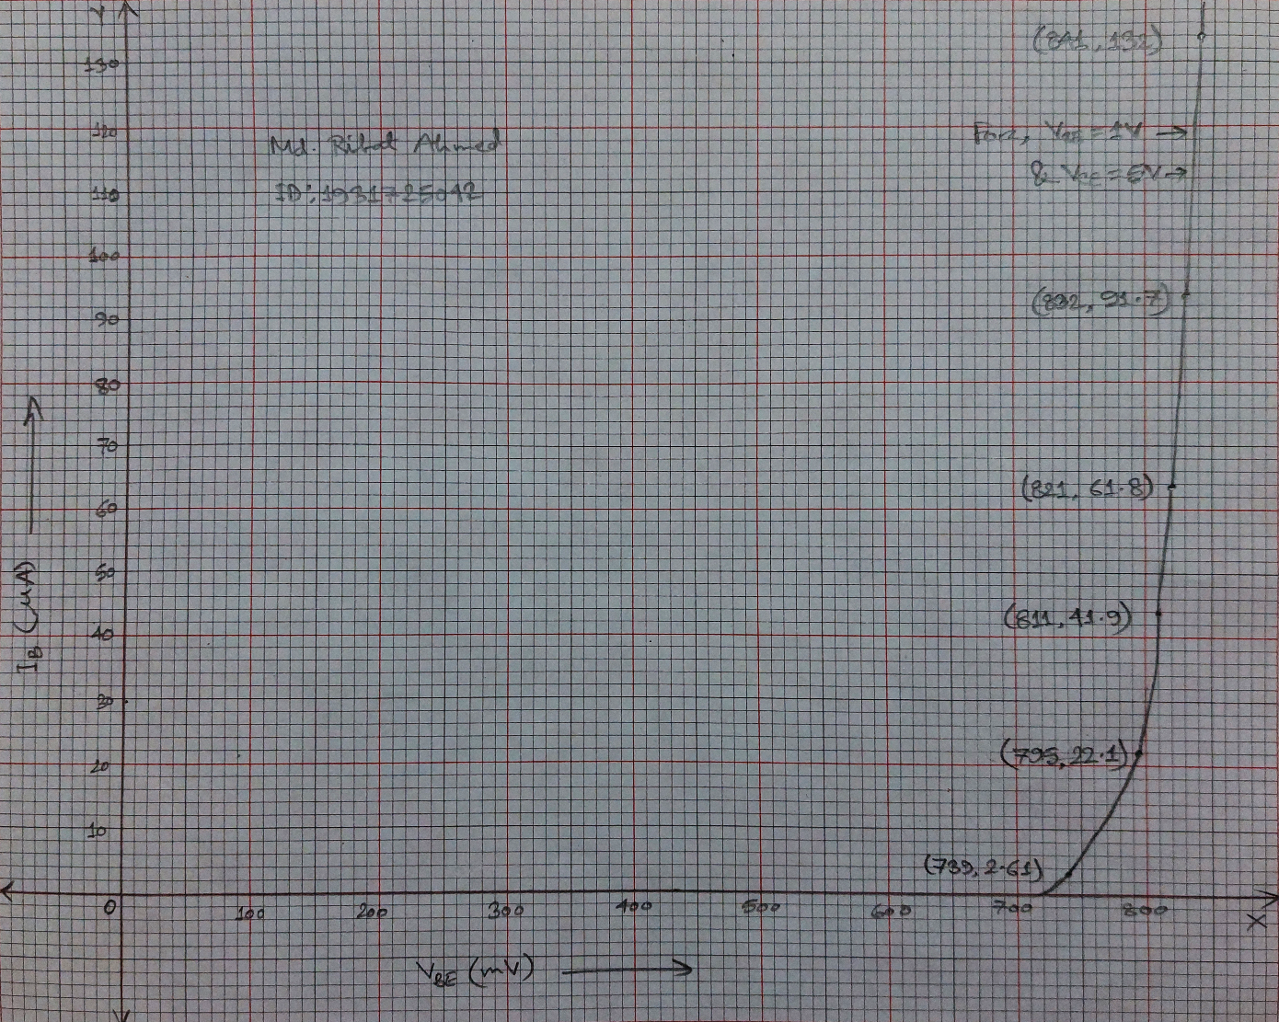

Figure 3 – Input Characteristics Graph of BJT for VCE = 1V & 5V

Here, we got the same values of IB and VBE for the given points for both VCE = 1V & 5V while simulating so the same line is representating both of them.

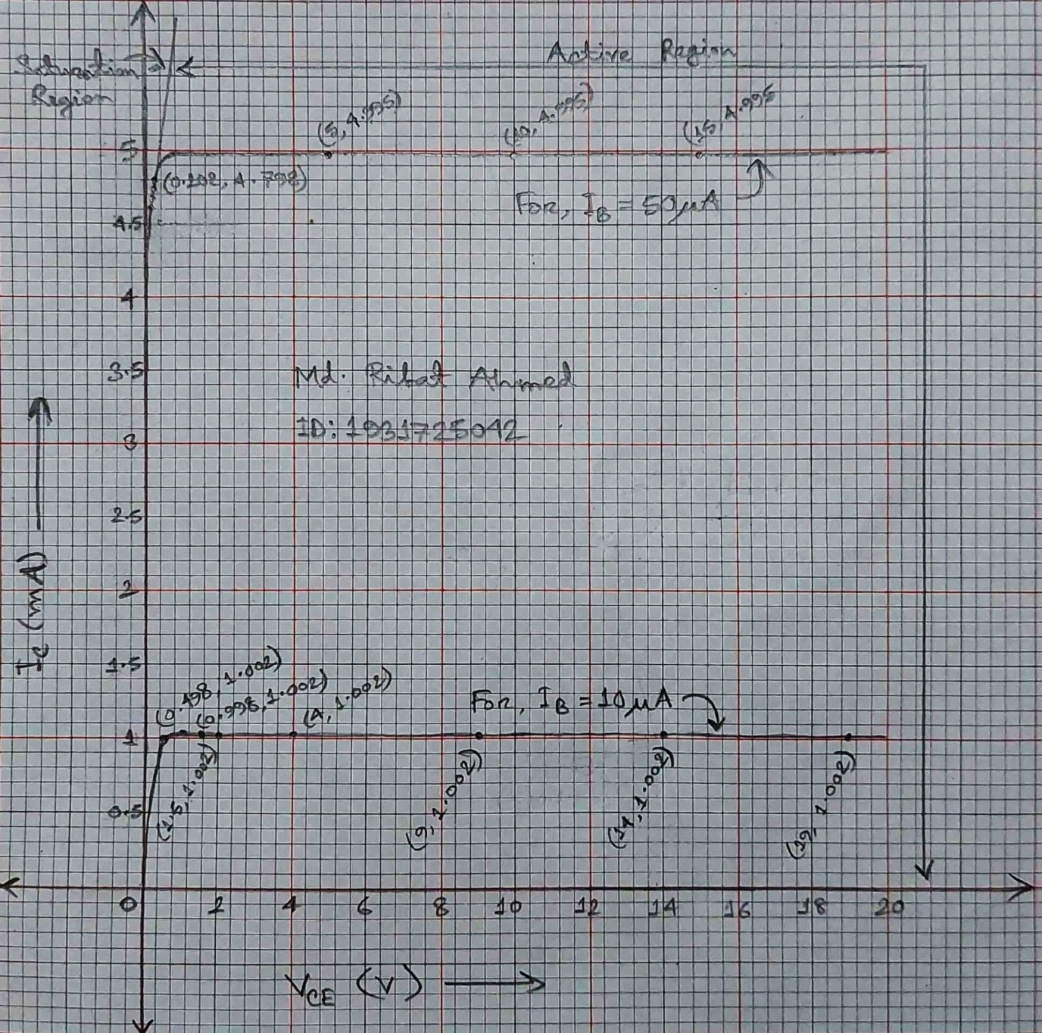

Figure 4 – Output Characteristics Graph of BJT for IB = 10µA & 50µA